SUPERSTORE SALES & PROFIT ANALYSIS — INSIGHT REPORT

Project Summary
“Analysed 5000+ transactions from Superstore to identify sales trends, loss-making categories, top-performing customers, and seasonal patterns using Python and Power BI. Built an interactive dashboard to visualize key business metrics and actionable insights.”

Skills demonstrated:
- Data cleaning & preprocessing (using Pandas and Numpy)
- Exploratory Data Analysis (EDA)
- Python (Matplotlib, Seaborn, Pandas)
- Power BI dashboard & DAX
- Business insight generation
================
Open above attached files to look into Data preprocessing.

Key Metrics / KPIs
Metric | Value / Insight
Total Sales | Sum of all orders
Total Profit | Sum of all profits (includes negative profits)
Profit Ratio | Profit / Sales, rounded to 2 decimals
Number of Loss-Making Orders | Count where Profit < 0
Top Customers | Customers generating highest profit
Top Loss-Making Products | Sub-categories contributing most losses

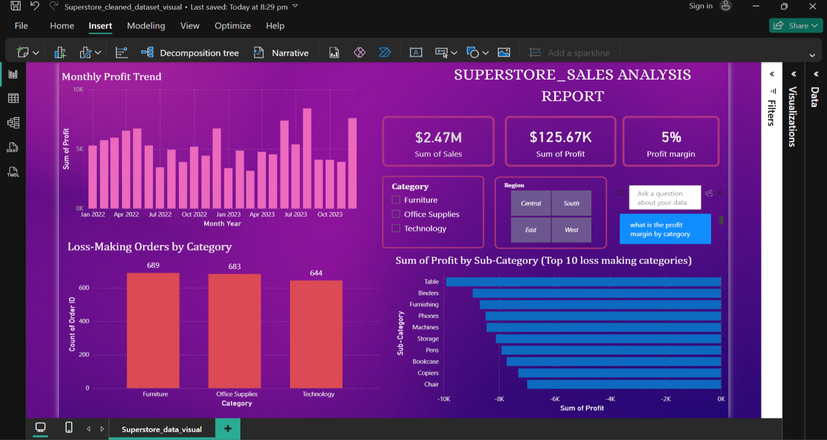

Business Insights

A. Category Analysis
- Furniture has highest sales, but some sub-categories like Bookcases and Chairs show negative profit ratios, indicating losses.
- Office Supplies has moderate sales with mostly positive profit, indicating steady profitability.
- Technology has fewer orders but higher profit per order on average. And have highest sales performance.

B. Loss-Making Analysis
- Top loss-making sub-categories: Tables, Binders, Furnishing, Phones, Machines, etc as shown in “sum of profit by sub-category top loss makers” visual. Tables is worst performing and amount higher loss among others.
- These require pricing review, discount strategy, or supplier renegotiation.
- Losses are concentrated in specific months, e.g., April–May, possibly due to seasonal promotions.

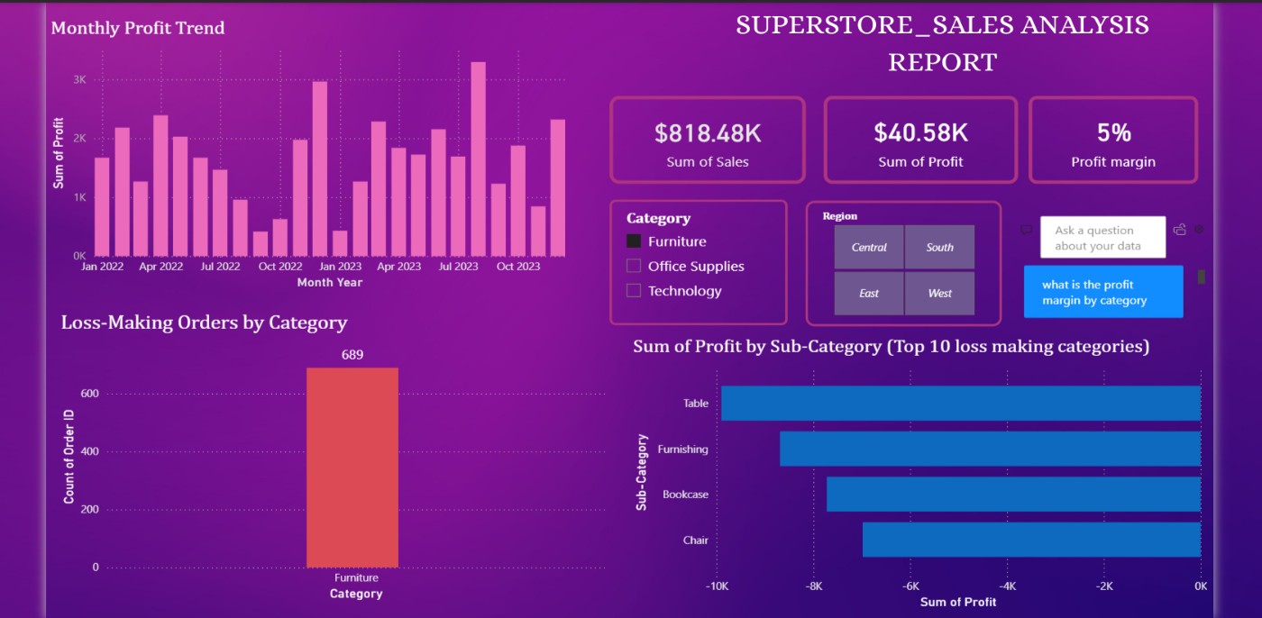

C. Time/Seasonality Trends
- Monthly profit trend shows losses in early months and peak profits in Q4.
- Indicates strong seasonal sales, aligns with holidays/office budget cycles.

D. Customer Insights
- Top 10 customers generate majority of profits.
- Personalized campaigns or loyalty programs for these customers can increase revenue.

E. Regional Analysis
- East & West regions contribute most to total sales .i.e. $1.24 Mn.
- Some regions show high losses in certain categories → opportunity for targeted operational improvements.

Dashboard Summary (Power BI)

Visualizations included:
- Monthly Profit Trend (Line Chart) – tracks overall profitability
- Loss-Making Orders by Category (Column Chart) – identifies problem categories
- Top 10 Loss-Making Sub-Categories (Bar Chart) – actionable product insights
- Total Sales, Profit, Profit Ratio (KPI Cards) – snapshot of performance
- Slicers – Category, Region, Year for interactive filtering

Actionable Recommendations
- Review pricing/discounts for loss-making sub-categories
- Focus on top customers for loyalty programs or targeted campaigns
- Plan inventory & marketing around peak months (Q4)
- Monitor regional performance and optimize logistics/profitability

Conclusion
“This project demonstrates the cleaning and analyzing raw business data, generate actionable insights, and visualize them in a professional, interactive Power BI dashboard. Recruiters can immediately see analytical, visualization, and business understanding skills.”

